Automotive Work Experience Toolkit
Students guide



Content

Introduction | Your Work Experience
About the IMI | Workbook – Before the placement
About Sytner Careers | Workbook – During the placement
Information for Students | Workbook – After the placement
About The Retail Motor Industry | Frequently Asked Questions

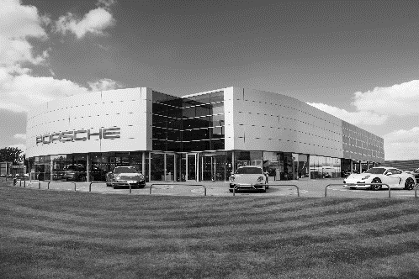

Introduction
The automotive industry influences everyone, from delivering goods on time to commuters travelling to work and emergency services being able to respond to a crisis, the motor industry helps keep the country moving.



About the IMI

The Institute of The Motor Industry (IMI) is the professional body for individuals working in the motor industry and the authoritative voice of the retail automotive sector. The IMI’s aim is to ensure that the automotive retail sector has a skilled, competent and professional workforce that is fully equipped to keep pace with the demands of new technology and changing markets. A key part of business for manufacturers and dealers is to encourage the best and brightest people to join their business in a variety of roles.



Information for students

Welcome! This is your first step into the exciting world of the motor industry.

By going on a work experience placement you will develop an understanding of:
- how a modern motor vehicle business works
- the world of work
- what skills, abilities and attitudes are required in the motor industry
- different jobs in the retail motor industry
The experience will also give you the opportunity to:
- put yourself forward to the business as a potential future employee
- make informed decisions about what type of career to follow
- link what you have learned in the classroom to the world of work
This toolkit has been produced to help employers and organisers make sure you get the most from your experience and it also contains a number of documents for you to use during your work experience placement.

The aim of your work experience placement, whether in a large dealership or a small workshop, is to gain an understanding of the world of work and let you find out how some of the skills and abilities learned at school can be applied in the real workplace.

By participating in a placement within the retail motor industry you will find out what it is like to work in this exciting environment and what career opportunities it offers.

Wherever your interest lies it is more than likely that there is a job suited to you within the retail motor industry. Based all over the country, every town will offer opportunities for employment because almost every town has garages selling, servicing, maintaining and repairing vehicles.

The retail motor industry

The retail motor industry is a large and complex part of the UK economy employing approximately 3% of the total national workforce, that’s around 570,000 people.

People working in the retail motor industry are employed in:

- the selling of cars, lorries, vans and motorcycles to private and business customers
- servicing and maintaining these vehicles to keep them safe and in working order
- roadside assistance and vehicle recovery helping motorists who have broken down or rescuing vehicles from the roadside
- assisting people that want to rent a vehicle or lease a number of vehicles
- the motorsports sector
- specialist rapid fit or ‘Fast-Fit’ outlets that are experts in tyre and exhaust fitting
- carrying out repairs to bodywork and paint after a crash or damage
- working in the parts sector providing components to business or customers

As people become experienced they can develop their careers by moving into a management role or by adding additional areas of expertise to their job by training to become an MOT tester for example.

A modern industry like the motor industry needs people skills in project management, research, finance, insurance, law, administration and marketing.

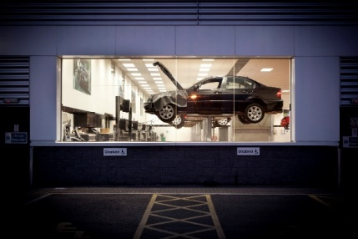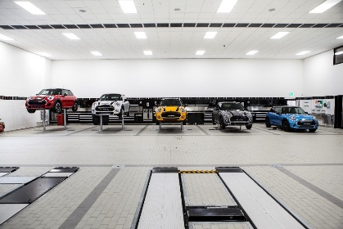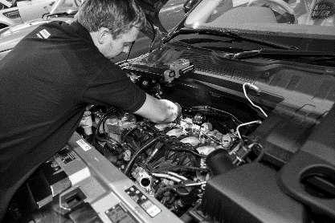

Your work experience
When you go on work experience it may be in a large garage where cars, trucks or motorcycles are sold and maintained. These are called dealerships and they form a large part of the automotive industry. People buy their cars from these dealerships and because the car will come with a warranty, they will often take the car back to this garage for it to be regularly serviced or repaired should something go wrong.

The people who work there know all about the types of cars they deal with and have direct links to the manufacturer, receiving specialist training from them. Whilst at a dealership like this you will ideally spend time in the different departments to find out how the business works and is organised.

Here is a list of some of the departments you might come across and what they do:

Service / Bodyshop Reception | Technical receptionists deal directly with customers both face to face and over the phone arranging for the service or repair of their vehicle. Many technical receptionists started out as technicians or just have an interest in cars, and use this technical knowledge to explain faults and repairs to customers.
Service Repair Workshop | Technicians service and maintain vehicles to ensure they are safe and reliable. Using hi tech equipment to diagnose and locate faults they replace work or faulty components or carry out routine service and maintenance to keep the vehicle operating at its optimum performance. There may also be technicians who work in specialist areas such as vehicle electronics or MOT testing.
Body Repair Workshop | With thousands of vehicles involved in scrapes every day the work of the body repair technician combined with the vehicle refinisher ensures the customer is kept happy by returning their vehicle to them restored to as new condition. This involves replacing panels and adopting many unique techniques to straighten damaged bodywork and prepare surfaces before ensuring the paint is perfectly matched to the original colour.
Parts Department | Parts operatives carry out a vital task in a dealership making sure that the correct parts and components are available at the right time; keeping the vehicle in the workshop for the minimum time possible. Combining administration skills with sophisticated IT systems the parts department ensures that stocks of parts are easily identified and located. Many parts departments also sell parts and accessories directly to the public demanding different skills and abilities such as handling cash.
Sales Department | The sales department is usually where most of the general public first become involved with a dealership and creating the right impression is important. Buying a car is often the second largest purchase a person makes, after buying a house, so making the right choice is extremely important. Sales executives use their knowledge of the vehicle range to provide help and advice to customers allowing them to choose the best option for them. Accurate paperwork is also important for the sales department and many use dedicated computer software packages to assist with processing sales orders.
Administration | No dealership can run without good administration; from accountants to human resources they keep the flow of documentation moving and records or vehicles, customers and staff are kept accurate and up to date. A large dealership will receive hundreds of forms, letters bills and payments from suppliers, customers and manufacturers every day, all of which need to be directed to the relevant department or recorded and filed appropriately.

Other opportunities for work experience also exist in smaller, independent garages. They may specialise in mechanical repairs or MOT testing, these garages are usually privately owned and are not directly linked to a specific manufacturer which means the people who work in them need to have a wide range of skills knowledge as they will work on all types of vehicles.

The body repair industry also has many independent workshops where a variety of accident damaged vehicles are repaired and painted. Some concentrate on older vehicles, restoring them back to new, others are experts at customising vehicles for special use. All of these areas require very specific skills and abilities.

Make the most of your work experience and explore the possibilities that working in the retail motor industry can offer!

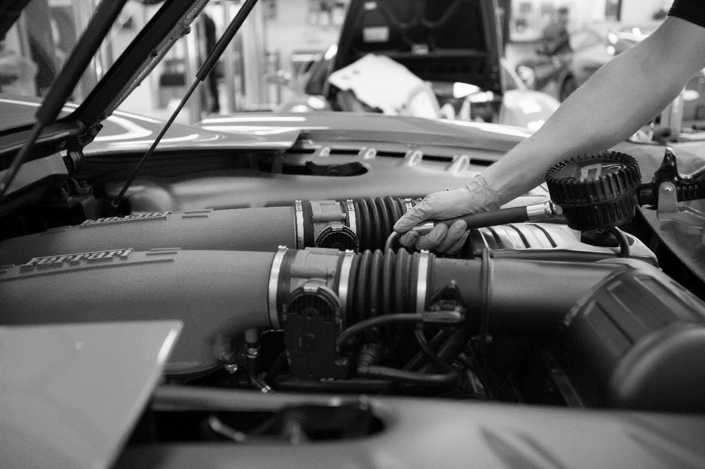
Workbook - Before the placement

- Self-Assessment - aims

Self-assessment – aims

Students name
School
Placement
Date from |  | Date to

To help assess how your own performance has developed you should identify three target areas for improvement during your work experience placement. You will need to agree these with your placement employer to ensure they are appropriate and achievable. To confirm you have completed the stated outcomes you will need to get a supervisor to sign the form to verify them.

Performance Improvement Targets |  | Achieved?  Delete as appropriate
1 |  | Yes / No
2 |  | Yes / No
3 |  | Yes / No

Supervisor confirmation of targets achieved:

_____________________________________________ (signature)

Workbook - During the placement

- Work experience diary – example
- Work experience diary – blank
- Workbook
- The Company
- My Company
- Health and safety
- Jobs within the company

Work experience placement diary – example

Use this form to record the daily tasks and activities you carry out during your work experience placement.

Work experience programme for | John Smith | At | ABC Motors

Day / Date | Morning | Where | Afternoon | Where
Monday 14th June | Induction with Jim Brown, Administration Manager. Was shown around dealership and met the people I will work with during my placement. Issued with overalls and boots. Agreed with Mr Brown my programme for the week. | Office | Went to service reception and helped the receptionist record details on the computer and passed job cards on to the workshop. Did the task to find out the repair status of the sales car damaged in a crash. | Reception
Tuesday 15th June | Worked with technician servicing a Volvo. Helped check systems on a new car before it went out for delivery to the customer. Chris showed me how to check tyres for wear to make sure they are safe & legal. | Service Workshop | Helps Chris to find a fault with a car that had no heater fan. Used special equipment to test wiring and found a faulty switch, fitted a new one. Helped John do an MOT on a Fiesta. | Service Workshop
Wednesday 16th June | Helped Bob in the parts department put spare parts into correct bins and used computer to find parts. Did exercise set by Mr Brown to get parts ready for delivery van. | Parts Department | Built display and put up posters for new oil promotion. Served mechanics at workshop counter. | Parts Department
Thursday 17th June | Went to training show on new car with sales department. Unpacked new car sales displays and posters. | Training Room | Set up new promotion in showroom. Put up posters and displays in windows. Helped move cars in from transporter and clean them. | Showroom
Friday 18th June | Did a challenge in sales department where I had to find best car for the Smith family. | Showroom & Office | Got to see what the office does with Steve and then Mr Brown had a chat about my week. Filled in my forms. | Office

Work experience placement diary

Use this form to record the daily tasks and activities you carry out during your work experience placement.

Work experience programme for |  | At

Day / Date | Morning | Where | Afternoon | Where

Work book
Work Experience allows you to apply the knowledge and skills leaned in the classroom to a real working environment and gain an appreciation of the world of work. Working in the motor industry can offer many exciting and rewarding challenges; this workbook will help you find out about your work experience company and the jobs within it.

- The questions can be done in any order but try to answer all of them
- If you are not sure about any questions, ask for help
- Answer in complete sentences, unless constructing a list, and you can use sketches too
- Use additional material if you can eg photos (ask permission first), brochures, company information sheets etc.

Student name |  | School
Name of business |  | Type of business
Address |  | Private owner
Address |  | Partnership
Address |  | Dealer group
Address |  | Franchise dealership
Address |  | Non franchise garage
Address |  | Fast fit outlet
Address |  | Other
Address |  | Public body



If they are a franchised dealership what does this mean? What franchise (s) do they have?

Has the placement more than one site? If so how many and where are they?

Describe the products and / or services they offer

The company

This section encourages you to find out about the company and how it is organised:

- Who owns the company and when was it founded?

- How many people work for the company at your placement location?

- Here is a chart showing the company structure of a typical motor dealership. Draw a similar chart showing the structure of your placement company. Include the names and titles of the heads of each department.

Dealer Principal

Sales Manager
Administration Manager
Parts Manager
Body shop Manager

Service Manager

2 Receptionists
2 Administrators
1 HR Assistant
1 Financial Controller
6 Sales Executives
1 Administrator

1 Body Receptionist
1 Workshop Controller
2 Body Repairers
2 Refinishers
2 Apprentices

2 Parts Operatives
1 Delivery Driver
1 Apprentice
2 Service Reception
1 Workshop Controller
6 Technicians
2 Apprentices
My company management chart

- As part of your induction you should have been given a tour of the workplace. From the list below tick off the departments / areas you have visited:

Reception |  | Showroom |  | Service Workshop
Parts Department |  | MOT Area |  | Carwash / Valet
Toilets |  | Canteen |  | Other
Body Repair Workshop |  | Administration Office |  | Other

- Describe any areas where you were not allowed to enter and why.

- What hours does the workplace operate?

- When are you expected to be there?

- What procedure is there for checking in and out of the workplace?

- When are your breaks?

- Describe what you think about the company e.g. friendly, busy etc.

- What is the dress code at your place of work? What safety clothing or equipment are you expected to wear?

Health and Safety

Motor vehicle workshops can be dangerous places and it is important you are aware of the systems and procedures in place to protect you and others around you in the workplace.

- What first aid facilities are provided and where are they? Is there a nominated first aider?

- What would you do if you had an accident in the workplace?

- Are there any tools, equipment or substances you’re not allowed to use?

- If you are going to be absent from work, who do you notify and how?

- How do you know when the fire alarm has been raised?

- How many fire extinguishers are in your work area?

- Where is the nearest emergency exit? Where is your assembly point?

- These are just some of the safety signs you may find around the workplace. Fill in what they mean and where they are.






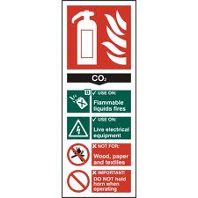

- List at least three safety hazards in your work area e.g. Flammable materials in the Bodyshop

1
2
3

The jobs within the company

It may be useful to arrange to interview someone you have worked with during your placement to help with some of the questions in this section.

- List some of the tasks and duties you are expected to perform on your work experience placement and the skills or knowledge needed to perform them.
Tasks & Duties | Skills / Knowledge Needed
Example: Identify and retrieve replacement parts using parts department computer system | Example: Ability to read and understand diagrams, use correct keys on the computer and follow storage location system to find exact location of part

- What tasks do you enjoy the most and why?

- What don’t you like about the placement and why?

- What qualifications would you need to have to do this job?

- What skills and abilities are needed? E.g. very fit, good with figures etc.

- How are people recruited for this job?

- What training do they receive?

- How long does it normally take to become fully qualified?

- How much could you earn in this job?

- What job opportunities are available in the company at the moment?

Signed:………………………………………….. Date: ………………………………….

Workbook - After the placement

- Review
- Self-Assessment – with employer or organiser
- Self-Assessment – aims

The review
This form will help you look back at your work experience and identify what you learned during the time spent in a real workplace environment. Use the workbook you completed during your placement and any assignments or projects you did as a reference to help you complete the questions.

Try to explain how the placement met, or didn’t meet your expectations; how it has helped you understand the world of work in general and how a business operating in the retail motor industry functions.

You may also find it useful to produce a report on your work experience. A report like this should be a story of the time spent with the company: who you met, what you did and what it was like. It should also identify things that you learned and how the skills and knowledge you learned at school were applied in a work situation.

How did the placement meet your expectations?
Were there any areas where your expectations were not met?
How did the work differ from what you expected?
How did being in a workplace compare to being at school?

Describe some of the jobs you were doing?
Which subjects from school helped during your placement and how?
What was good about the job? Way was this good?
What didn’t you like about the job?
Is there any advice you would give someone considering the same placement?
How did you get on with the people who worked there?

Did the pre-placement guidance help you understand the work any better?
What support did the workplace give you while you were there?
How did you learn how the business operates?
Are there any skills / abilities you feel you’ve improved on since the placement?
Are there any skills / abilities that the placement has shown you need to improve?
How could you sell the work experience you’ve had to a future employer?
Explain how your understanding of how a motor industry business operates has changed.

What kinds of jobs were there that you didn’t expect / know about?
Would you consider a career in the retail motor industry and why?
If yes, what do you need to do next?



Now you need to write a letter or email of thanks to the employer who provided your work experience placement. Your teacher will help you with the lay-out of the letter and with any spelling or punctuation. Draft your letter first and let your teacher check it before writing the final version.

Self-assessment – with employer or organiser

You should complete the following sections and get them confirmed by asking your supervisor to mark yes or no as appropriate and signing in the right hand column.

Detail a number of tasks which you undertook with limited or no supervision. | Confirmed by supervisor?  Yes / No  Supervisor’s signature
Give an example of when you dealt effectively with an unexpected situation and responded to it in a positive manner. | Confirmed by supervisor?  Yes / No  Supervisor’s signature
Give an example of when you had to think for yourself and use your initiative. | Confirmed by supervisor?  Yes / No  Supervisor’s signature
Give a time when you asked for advice or help from others. | Confirmed by supervisor?  Yes / No  Supervisor’s signature
Give a time when you volunteered opinions or gave advice to others. | Confirmed by supervisor?  Yes / No  Supervisor’s signature
Give an example which shows how you worked well and co-operated with others. | Confirmed by supervisor?  Yes / No  Supervisor’s signature

Self-assessment – aims

Now look back at the targets you set. Have you achieved them?

Targets |  | Achieved?
1 |  | Yes / No
2 |  | Yes / No
3 |  | Yes / No

Supervisor confirmation of targets achieved (or not):

_______________________________________________________ (signature)

_______________________________________________________ (print name)

_________________________________ (date)

Frequently asked questions about work experience placements

What will I do on my work experience?
You will gain an understanding of the world of work and the skills, abilities and attitudes you will require to be successful in the workplace and how these relate to your school work. You will experience what it is like to be employed in the retail motor industry and, depending on the size and type of company, the range of jobs available. You may work with people in technical roles repairing vehicles in the workshops, assisting service advisors and receptionists dealing with customers, providing admin back up to ensure the garage runs smoothly, or supporting the sales and parts departments. A work experience placement can provide an insight into what a job in the motor industry is like and help you to make informed decisions about our future.

Will I attend at the same times as when I am at school?
The hours you attend work experience will be agreed with the employer and your placement organiser. However, for you to gain a real insight into the world of work and experience the daily routine, you should expect your working day to be the same as the people you will be working beside.
What if I find this isn’t the job I want to do?
Then you have learned something from the experience and will be able to rethink your career plans. Even if you find that a job in the motor industry is not what you expected, you will have gained a valuable understanding of what the world of work is like. Things like team work, communication, good timekeeping and appearance are important in any job and every work experience placement provides the opportunity to see why these matter, helping you prepare for the career you eventually decide is right for you.
Will potential employers recognise my work experience?
Yes. Employers realise the benefit of work experience and are more likely to recruit someone who has attended a work experience placement. You may be given a certificate recognising a successful placement and you should ensure that details of your placement are added to your CV. Many work experience placements can lead to an offer of a job.

Where can I find information on degree courses and university work placements?
The IMI has launched a new Graduate and Undergraduate section on our Jobs Platform, where applicants can now search for degree-level opportunities, internships and gap-year placements alongside apprenticeship vacancies: www.imijobs.org.uk

How can I prepare my students for work experience in the motor industry?
Included in the toolkit is a section for your students with guidance and information to ensure they are well prepared for their work experience in our industry.

I already have information for organising my placements. How will this toolkit help me?
The Automotive Work Experience Toolkit has been designed specifically for work experience within the automotive sector, providing guidance and information on how to ensure your students gain the best experience in our industry. The toolkit includes all the necessary forms and documents to help you set up and manage an automotive work experience placement. It also provides your students and the employers you work with tasks and projects which will help them structure their time in the workplace highlighting the range of skills and abilities needed by the retail motor industry.
Employers in my area are reluctant to get involved. What can I do?
Many smaller employers in our sector find it difficult to organise and manage the work experience placement and therefore find it easier not to become involved. By providing them with guidance on how to go about it, with a structured programme they can work to and pre-prepared documentation you can make the process as straightforward as possible. Hopefully this will ensure that a hassle free, enjoyable and high quality work experience placement is provided. Once on board employers can be encouraged to participate in other activities such as school visits/talks, teacher placements, mock interviews etc - strengthening relationships with their local schools and the local community.

Can I download/print the forms?
All the documents are in pdf format and available for you to download and print.

For more information please visit www.theimi.org.uk/autocity

Contact us with any questions, queries or feedback on careers@theimi,org.uk

The IMI Careers Team

