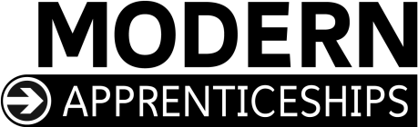

A

MODERN APPRENTICESHIP

IN

AUTOMOTIVE
at

SCQF Level 6/7

FRAMEWORK DOCUMENT FOR
SCOTLAND

Institute of the Motor Industry (IMI)

March 2017

Updated May 2018 to include new qualification numbers

Institute of the Motor Industry (IMI) Fanshaws
Brickendon
Hertford
SG13 8PQ

Contents

Modern Apprenticeships in Scotland 3

Modern Apprenticeships in Automotive 4

Summary of Framework 5

The Framework 7

Registration and certification 9

Recruitment and selection 10

Equal opportunities 11

Health and safety 11

Contracts 11

Employment status of Modern Apprentices 11

Terms and conditions of employment 11

Training and development 12

Consultation 13

Career progression 15

Appendices

Appendix 1 | Stakeholder Responsibilities | 16
Appendix 2 | Modern Apprenticeship Centres (MACs) | 19
Appendix 3 | Training Agreement and Training Plan | 20

Modern Apprenticeships in Scotland

What are Modern Apprenticeships?

Modern Apprenticeships offer those aged over 16 paid employment combined with the opportunity to train for jobs at craft, technician and management level.

Who develops them?

Modern Apprenticeships are developed by Sector Skills Councils (SSCs). SSCs consult with employers and key partners in their sector to produce a training programme, which meets the needs of employers.

Who are they for?

Modern Apprenticeships are available to employees aged 16 or over. Employees need to demonstrate to their employer that they have the potential to complete the programme.

What’s in a Modern Apprenticeship?

In Scotland, there are more than 70 different Modern Apprenticeship Frameworks and they are all designed to deliver a training package around a minimum standard of competence defined by employers through SSCs. They all contain the same 3 basic criteria:

A relevant S/NVQ (or alternative competency based qualifications)
Core Skills
Industry specific training

Details of the content of this specific Modern Apprenticeship are given in the next section.

Modern Apprenticeships in Automotive

Overview of the sector

The IMI footprint covers the UK automotive retail sector. This includes a multitude of activities including employers engaged in all aspects of the sale, repair and maintenance of vehicles as well as services to owners and users of passenger cars, motorcycles, light and heavy vehicle commercial vehicles, specialist vehicles and associated equipment. The sector footprint also includes the rental and leasing of vehicles and some motorsport activities.

According to the latest Office for National Statistics (2014), the Scottish automotive retail sector currently employs approximately 48,700 people, which accounts for 2% of the total Scottish workforce (2.5 million) and 8% of the total UK Automotive Retail workforce. The number of people in employment has increased by 1% from 2013. There are approximately 4,720 automotive retail enterprises that operate across Scotland,² which equates to 1.09% increase from the previous year's figures. The Automotive Retail sector contributes £13.1 billion¹ to the Scottish economy, which equates to 11% of the total Scottish Gross Value Added (GVA) figure. The UK automotive retail industry as a whole generated £171 billion GVA, which equates to 12% UK GVA.

Continued efforts to reduce greenhouse emissions by world leaders have resulted in car manufacturers adopting new technologies to drive down emissions. This, coinciding with the development of autonomous and alternative fuel cell vehicles, has propelled the automotive sector to the forefront of technological advancement. The Society of Motor Manufactures and Traders (SMMT) has suggested that the overall social benefit of these technological change could be in the region of an additional £51bn per year by 2030 and the creation of an additional 320,000 jobs³.

The advancing technological change in the automotive sector has meant that new Electric Vehicles and Fuel Cell Hybrid Vehicles have few similarities with the traditional combustion engine. Cars of the future will require potentially less input from the driver and there will be a greater reliance on the technology to perform the transportation as well as protect the travellers and the environment outside of the car. These cars will require the human infrastructure involved in the maintenance and repair to be highly skilled and knowledgeable in complex electronic and software control systems, who can also access continued training and development. Therefore, the industry requires bright, highly trained recruits who can adapt to this ever changing technological environment ensuring we continue to have the skills within our Scottish workforce to service, maintain and repair the complex modern motor vehicle.

This framework was last updated in 2011 and so required a full review and update. Revised SVQ and Diploma qualifications were added into the framework for January 2016 and we will be adding newly revised Paint and Body qualifications during 2017/18. The new SVQs and Diplomas saw the introduction of units that cover knowledge and competence on Electric and Hybrid Vehicles which support the requirements of the sector as listed above.

This Modern Apprenticeship framework at SCQF Level 6/7 offers opportunity for progression for those who have completed a framework at SCQF Level 5 or can be an entry route into the sector in its own right. The inclusion of the SCQF Level 5 and 6/7 Vocationally related Qualification (VRQs) as mandatory enhancements to supplement the SVQ, ensures that individuals have the necessary breadth of essential knowledge to competently and responsibly, carry out the tasks their job demands.

1 http://web.ons.gov.uk/ons/datasets/slice/csv/CSV_RegGVA012015EUROSTATH_EN_338821.zip
2 Office for National Statistics (ONS) for 2014 published in 2016
3 http://www.smmt.co.uk/wp-content/uploads/sites/2/CRT036586F-Connected-and-Autonomous-Vehicles-%E2%80%93-The-UK-Economic-Opportu...1.pdf
Summary of Framework

Diagram showing the contents of the Modern Apprenticeship in Automotive

Mandatory outcomes

SVQs at SCQF Level 6/7 or Alternative Competence Based Qualifications

Each Modern apprentice is required to achieve one of the following SCQF Level 6/7 Scottish Vocational
Qualifications (SVQs) or alternative competence based appropriate to the pathway being followed:

Vehicle Maintenance and Repair
C&G: SVQ in Light Vehicle Maintenance and Repair at SCQF Level 7 GL84 47
IMI: SVQ Light Vehicle Maintenance and Repair at SCQF Level 7 GL88 47
C&G: SVQ in Heavy Vehicle Maintenance and Repair at SCQF Level 7 GL86 47
IMI: SVQ Heavy Vehicle Maintenance and Repair at SCQF Level 7 GL8A 47
IMI: SVQ Motorcycle Maintenance and Repair at SCQF Level 7 GL8D 47
IMI: Diploma in Lift Truck Maintenance and Repair Competence at SCQF Level 7 R246 04

Vehicle Body and Paint
C&G: SVQ in Vehicle Body Repair and Alignment at SCQF Level 6 GN9Y 46
IMI: SVQ in Vehicle Body Repair and Alignment at SCQF Level 6 GN9A 46
C&G: SVQ in Vehicle Paintwork Repair at SCQF Level 6 GN9X 46
IMI: SVQ in Vehicle Paintwork Repair at SCQF Level 6 GN9D 46 IMI SVQ in Vehicle Accident Repair Mechanical, Electrical and Trim (MET) at SCQF Level 6 GG2V 23

Vehicle Parts
IMI: SVQ Vehicle Parts Operations at SCQF Level 6 GN9F 46

Core Skills

All of the following Core Skills must be separately certificated

Communication SCQF Level 5
Numeracy SCQF Level 5
Information Technology SCQF Level 5
Working with Others SCQF Level 5
Problem Solving SCQF Level 5
Enhancements

Each Modern apprentice is required to achieve one of the following SCQF Level 5 AND SCQF Level 6/7 Vocationally Related Qualifications (VRQs) appropriate to the pathway being followed:

Vehicle Maintenance and Repair

SCQF Level 5:
C&G: Diploma in Light Vehicle Maintenance and Repair Principles at SCQF Level 5 R492 04
IMI: Diploma in Light Vehicle Maintenance and Repair Principles at SCQF Level 5 R498 04
C&G: Diploma in Heavy Vehicle Maintenance and Repair Principles at SCQF Level 5 R494 04
IMI: Diploma in Heavy Vehicle Maintenance and Repair Principles at SCQF Level 5 R500 04
IMI: Diploma in Motorcycle Maintenance and Repair Principles at SCQF Level 5 R496 04
IMI: Diploma in Lift Truck Maintenance and Repair Principles at SCQF Level 5 R221 04

SCQF Level 6/7:
C&G: Diploma in Light Vehicle Maintenance and Repair SCQF at Level 7 R493 04
IMI: Diploma in Light Vehicle Maintenance and Repair SCQF at Level 7 R499 04
C&G: Diploma in Heavy Vehicle Maintenance and Repair Principles at SCQF Level 7 R495 04
IMI: Diploma in Heavy Vehicle Maintenance and Repair Principles at SCQF Level 7 R501 04
IMI: Diploma in Motorcycle Maintenance and Repair Principles at SCQF Level 7 R497 04
IMI: Diploma in Lift Truck Maintenance and Repair Principles at SCQF Level 7 R222 04

Vehicle Body and Paint

SCQF Level 5:
C&G: Diploma in Vehicle Body Repair at SCQF Level 5 R557 04
IMI: Diploma in Vehicle Body Repair at SCQF Level 5 R563 04
C&G: Diploma in Vehicle Accident Repair Paint Principles at SCQF Level 5 R559 04
IMI: Diploma in Vehicle Accident Repair Paint Principles at SCQF Level 5 R561 04
IMI: Diploma in Accident Repair Mechanical, Electrical and Trim (MET) Principles at SCQF Level 5 R223 04

SCQF Level 6/7:
C&G: Diploma in Vehicle Body Repair and Alignment Principles at SCQF Level 6 R558 04
IMI: Diploma in Vehicle Body Repair and Alignment Principles at SCQF Level 6 R564 04
C&G: Diploma in Vehicle Accident Repair Paint Principles at SCQF Level 6 R560 04
IMI: Diploma in Vehicle Accident Repair Paint Principles at SCQF Level 6 R562 04
IMI: Diploma in Accident Repair Mechanical, Electrical and Trim (MET) Principles at SCQF Level 6 R224 04

Vehicle Parts

SCQF Level 5:
IMI: Diploma in Vehicle Parts Principles at SCQF Level 5 R565 04

SCQF Level 6/7:
IMI: Diploma in Vehicle Parts Principles at SCQF Level 6 R566 04

Optional Outcomes

Additional S\NVQ Units/Qualifications/Training

None

The Framework

The mandatory and optional content of the Modern Apprenticeship in Automotive is as follows:

Mandatory Outcomes

S\NVQ(s)

Each Modern Apprentice is required to achieve one the following SCQF 6/7 Scottish Vocational Qualifications
(SVQs) appropriate to the pathway being followed:

Vehicle Maintenance and Repair
 C&G: SVQ in Light Vehicle Maintenance and Repair at SCQF Level 7 GL84 47
IMI: SVQ in Light Vehicle Maintenance and Repair at SCQF Level 7 GL88 47
 C&G: SVQ in Heavy Vehicle Maintenance and Repair at SCQF Level 7 GL86 47
IMI: SVQ in Heavy Vehicle Maintenance and Repair at SCQF Level 7 GL8A 47
IMI: SVQ in Motorcycle Maintenance and Repair at SCQF Level 7 GL8D 47
IMI: Diploma in Lift Truck Maintenance and Repair Competence at SCQF Level 7 R246 04

Vehicle Body and Paint
 C&G: SVQ Vehicle Body Repair and Alignment at SCQF Level 6 GN9Y 46
 IMI: SVQ Vehicle Body Repair and Alignment at SCQF Level 6 GN9A 46
 C&G: SVQ Vehicle Paintwork Repair at SCQF Level 6 GN9X 46
 IMI: SVQ Vehicle Paintwork Repair at SCQF Level 6 GN9D 46
IMI: SVQ Vehicle Accident Repair Mechanical, Electrical and Trim (MET) at SCQF Level 6 GG2V 23

Vehicle Parts
IMI: SVQ Vehicle Parts Operations at SCQF Level 6 GN9F 46

Scottish Vocational Qualifications (SVQs) are work-based qualifications, which are based on National Occupational Standards of competence drawn up by representatives from each industry sector. SVQs are made up of units – normally between six and ten – which break a job down into separate functions reflecting the different kinds of activities of a job. SVQs are available at five levels – although most are at SCQF Level 5, 6 and 7. When someone has achieved an SVQ, there is a guarantee that they have the skills and knowledge needed to do their job. All Scottish Modern Apprenticeships must contain a relevant SVQ (or NVQ) or equivalent qualification.

Core Skills

Each Modern apprentice is required to achieve the following core skills:
Communication SCQF Level 5
Numeracy SCQF Level 5
Information and Communication Technology SCQF Level 5
Working with Others SCQF Level 5
Problem Solving SCQF Level 5

Core skills units are available from a number of Awarding Bodies and are required to be separately certificated. Please see SQA Accreditation website for more information.

Core Skills are skills and abilities which everyone needs in their work. This is true for every job in every workplace. Core Skills also feature in National Qualifications such as Standard Grades and Highers and from 2000 Scottish candidates have been issued with a Core Skills profile on their Scottish Qualifications Certificate. Candidates who have already been certificated as achieving Core Skills at the levels given above – either in the workplace or at school or college - do not need to repeat these Core Skills as part of the Modern Apprenticeship Framework.

Enhancements

Each Modern Apprentice is required to achieve one the following SCQF Level 5 AND SCQF Level 6/7 Vocationally Related Qualifications (VRQ’s) appropriate to the pathway being followed:

Vehicle Maintenance and Repair

SCQF Level 5:
 | C&G: Diploma in Light Vehicle Maintenance and Repair Principles at SCQF Level 5 | R492 04
 | IMI: Diploma in Light Vehicle Maintenance and Repair Principles at SCQF Level 5 | R498 04
 | C&G: Diploma in Heavy Vehicle Maintenance and Repair Principles at SCQF Level 5 | R494 04
 | IMI: Diploma in Heavy Vehicle Maintenance and Repair Principles at SCQF Level 5 | R500 04
 | IMI: Diploma in Motorcycle Maintenance and Repair Principles at SCQF Level 5 | R496 04
 | IMI: Diploma in Lift Truck Maintenance and Repair Principles at SCQF Level 5 | R221 04

SCQF Level 6/7:
 | C&G: Diploma in Light Vehicle Maintenance and Repair SCQF at Level 7 | R493 04
 | IMI: Diploma in Light Vehicle Maintenance and Repair SCQF at Level 7 | R499 04
 | C&G: Diploma in Heavy Vehicle Maintenance and Repair Principles at SCQF Level 7 | R495 04
 | IMI: Diploma in Heavy Vehicle Maintenance and Repair Principles at SCQF Level 7 | R501 04
 | IMI: Diploma in Motorcycle Maintenance and Repair Principles at SCQF Level 7 | R497 04
 | IMI: Diploma in Lift Truck Maintenance and Repair Principles at SCQF Level 7 | R222 04

Vehicle Body and Paint

SCQF Level 5:
C&G: Diploma in Vehicle Body Repair at SCQF Level 5 | R557 04 | GC6E 23   C&G: SVQ 3 Vehicle Paintwork Repair at SCQF Level 6 GD07 23   IMI: SVQ 3 Vehicle Paintwork Repair at SCQF Level 6 GC63 23  IMI SVQ 3 Vehicle Accident Repair Mechanical, Electrical and Trim (MET) at SCQF Level 6 GG2V 23
IMI: Diploma in Vehicle Body Repair at SCQF Level 5 | R563 04
C&G: Diploma in Vehicle Accident Repair Paint Principles at SCQF Level 5 | R559 04
IMI: Diploma in Vehicle Accident Repair Paint Principles at SCQF Level 5 | R561 04
IMI: Diploma in Accident Repair Mechanical, Electrical and Trim (MET)Principles at SCQF Level 5 | 5 R223 04

SCQF Level 6/7:
C&G: Diploma in Vehicle Body Repair and Alignment Principles at SCQF Level 6 R558 04
IMI: Diploma in Vehicle Body Repair and Alignment Principles at SCQF Level 6 R564 04
C&G: Diploma in Vehicle Accident Repair Paint Principles at SCQF Level 6 R560 04
IMI: Diploma in Vehicle Accident Repair Paint Principles at SCQF Level 6 R562 04
IMI: Diploma in Accident Repair Mechanical, Electrical and Trim (MET) Principles at SCQF Level 6 R224 04

Vehicle Parts

SCQF Level 5:
IMI: Diploma in Vehicle Parts Principles at SCQF Level 5 R565 04

SCQF Level 6/7:
IMI: Diploma in Vehicle Parts Principles at SCQF Level 6 R566 04

Optional Outcomes

Registration and certification

This Scottish Modern Apprenticeship is managed by Institute of the Motor Industry (IMI), Sector Skills Council for the
Retail Motor Industry. The SSC is the first point of contact in Scotland for any enquiries in relation to the Framework.

Contact details:

Institute of the Motor Industry (IMI) Fanshaws
Brickendon Hertford SG13 8PQ
Tel: 01992 519039
Fax: 01992 511548

The SSC will register all Scottish Modern Apprentices undertaking this Framework. All Modern Apprentices must be registered with the SSC within 4 weeks of starting their apprenticeship. Registration should be completed using the online registration system MA Online. (www.maonline.org.uk). A completed Training Plan and Training Agreement must also be held and samples of these are available in Appendix 3.

The SSC will issue a Modern Apprenticeship Certificate of Completion to those Modern Apprentices who have completed the mandatory outcomes of the Framework. Before a certificate is issued, training providers must submit evidence to the SSC that the mandatory outcomes have been achieved. This will normally be in the form of copies of certificates from awarding bodies.

Requests for registration and certification should be made to the SSC via MA Online or at the address above.

SSC Service level

The SSC undertakes to confirm the registration of candidates in writing within 4 weeks of receipt of the relevant Training
Plan and Training Agreement. Each candidate will be issued with a unique registration number.

The SSC also undertakes to issue Certificates of Completion within 4 weeks of receipt of the appropriate evidence that a candidate has completed the outcomes as stated in the Training Plan.

Recruitment and selection

The recruitment and selection of Modern Apprentices is primarily the responsibility of the employer. However, the following guidance is given:

- Employees may enter a Modern Apprenticeship from the age of 16. There is no upper age limit.

- The Modern Apprenticeship is designed to attract high quality people to the industry. Achievement of academic qualifications is one way of assessing the suitability of applicants. However it should be stressed that no persons should be deterred from applying for a Modern Apprenticeship because of a lack of formal educational qualifications. As well as traditional qualifications such as Standard Grades and Highers, employers should also be aware of newer vocational qualifications or vocational activity undertaken outwith an academic institutions, such as volunteering activity.

- The following factors may also influence the selection process:

  - performance during a formal interview process
  - references
  - relevant work experience
  - trial observation period

- Employers should be aware of the nature, relevance and quality of foreign qualifications and make appropriate allowances concerning entry requirements.

- In order to promote and maintain the high status of the Modern Apprenticeship within the industry all literature distributed for recruitment purposes should emphasise the high standards of achievement expected of the candidate.

- Employers may wish to contact the SSC for advice and guidance on recruitment and selection.

Although there are no formal entry requirements it is recommended that candidates commencing on this Modern Apprenticeship programme should have achieved as a minimum a National 4 in English, Maths and a Science subject. It is also desirable that an appropriate initial assessment test is undertaken.

Candidates should possess an interest in things mechanical and be able to demonstrate a commitment to working in the industry. This could be through school link courses, work experience programmes or voluntary/part time work.

There is also a further recommendation that a robust induction procedure is in place which includes Equal
Opportunities and Employment Rights and Responsibilities.

Equal opportunities

Modern Apprenticeships should ensure that there is equality of opportunity for all and any barriers (real or perceived) are addressed to support anyone seeking to enter employment to undertake the Modern Apprenticeship.

All MAs supported by Skills Development Scotland must conform to any contractual requirements on equal opportunities. All employers of Modern Apprentices should have an Equal Opportunities policy statement.

Health and Safety

All aspects of health and safety at work must be recognised within the delivery of this Modern Apprenticeship Framework and all statutory requirements be adhered to.

It is a key aspect of the induction period of the Modern Apprenticeship that apprentices are fully informed both of the regulations and that they and their employers are bound by these regulations. Modern Apprentices should be made aware of their rights and duties with regard to health and safety.

All Modern Apprentices supported by Skills Development Scotland will be required to satisfy the adequacy of SDS’s Health and Safety policy and systems.

Contracts

The following three contracts are essential to the successful outcome of the Modern Apprenticeship programme:

1 Contract of employment signed by the employer and the Modern Apprentice.

2 SSC Training Agreement - this agreement outlines the basis of the modern apprenticeship, refers to the contract of employment and includes Health and Safety responsibilities.

3 SSC Training Plan - this plan outlines the selected outcomes and the expected duration of the apprenticeship. In cases where funding is offered by a SDS area office, the SDS Training Plan will be sufficient on condition that it contains all relevant information as set out in the MA Training Plan at Appendix 2. Training Plans may be modified to reflect changing circumstances, however it is essential that the SSC is notified of any changes.

Employment status of Modern Apprentices

It is important that the sector offers genuine employment and career prospects to those people it wishes to attract through Modern Apprenticeships. Accordingly, all apprentices must be employed for the duration of the apprenticeship.

Terms and conditions of employment

In order to compete with other sectors offering Modern Apprenticeships, attractive packages will need to be developed by employers in the sector. The terms and conditions of employment for individual Modern Apprentices will be agreed between the employer and the apprentice and should form the contract of employment.

Training and development

Delivery

Training delivery can take many forms under the Modern Apprenticeship system. Some organisations may become approved S/NVQ Assessment Centres; others may join a consortium or use peripatetic assessors. Some large employers will be able to complete all the training and development in-house, but most employers will find that some of the training and development will have to take place away from the normal workplace. In particular the underpinning knowledge requirements are often more suited to delivery by outside training providers which might include:

- private training organisations
- colleges / universities
- other employers

Such knowledge could be delivered through training courses or through open/distance learning packages.

The option of sharing training and assessment resources amongst a cluster of employers (or across the divisions of a larger employer) will be particularly appealing to those firms which do not have the resources to provide all of the training and development. Assessment can be provided by these bodies, but the assessors and the training centre must be approved by the awarding bodies for the S/NVQ and Core Skills where appropriate.

Please contact the Sector Skills Council for an up to date list of providers approved to deliver this framework or visit the Scotland pages of the IMI website at www.theimi.org.uk where the list is published.

The SSC training plan

The plan is required to identify:

1 | The selected Framework outcomes, specifying whether or not separate certification of the Core  Skills is being sought.
2 | A summary of the Modern Apprentices accredited prior learning
3 | A timetable for achievement of the selected Framework outcomes, linked to regular progress reviews.

The Training Plan should take into account any relevant previous training and development, education or work experience. Not all Modern Apprentices need have different plans, but many will vary. Moreover as reviews take place and circumstances change so the plan itself can be modified.

However any changes must:

- be subject to the quality provisions of Skills Development Scotland (if the MA is being financially supported)
- comply with the stipulations of this Framework
- meet the needs of the employer and apprentice.

A sample Training Plan is provided at Appendix 3 of this document, however, for those Modern Apprentices funded by
SDS area office it is sufficient to submit the Skills Development Scotland Training Plan on condition that it covers the same
information required in the MA Training Plan.

Consultation Process

Consultation on the revisions for this framework took place using face to face meetings, a consultation webpage, online survey, consultation forms and telephone conversations. The employers consulted include:

Automotive Dealer Groups (Service Maintenance and Repair, Fast fit, Accident Repair, Parts, Sales, Vehicle Rental and
Leasing)

Arnold Clark Automobiles
John Clark Motor Group Parks Motor Group Peoples Ltd
Phoenix Car Company
Independent Garages (Service Maintenance and Repair, Accident Repair, Parts, Sales)

Allied Vehicles

Rapid Fit (Fast Fit, Service, Maintenance and Repair)

Kwik Fit

Parts Distribution (Parts)

Dingbro Ltd

Trade Associations (All Areas)

SMTA – Scottish Motor Trade Association (806 member companies)
VBRA – Vehicle Builders and Repairers Association (25 member companies)

Local Authorities

Represented by Dundee City Council

Colleges, Training Providers and the two awarding bodies (city and Guilds and IMI) were also consulted using a variety of methods:

City and Guilds
Institute of the Motor Industry (IMI)
GTG Training
Moray Firth Training Group
New College Lanarkshire
North Glasgow College
Perth College
ReMIT Scotland
West Lothian College

The outcome of the consultations saw changes on the following:

Retention of the current pathways offered at levels 6 and 7
Continued inclusion of the VRQs as mandatory enhancements to the framework ensuring adequate underpinning knowledge is included within the MA programme
Retention of the requirement for separate certification of all Core Skills
Removal of ATA as an optional outcome of the framework
Additional job roles added as possibilities of Career progression

Following the completion of the Modern Apprenticeship, candidates should be able to achieve positions in areas such as:
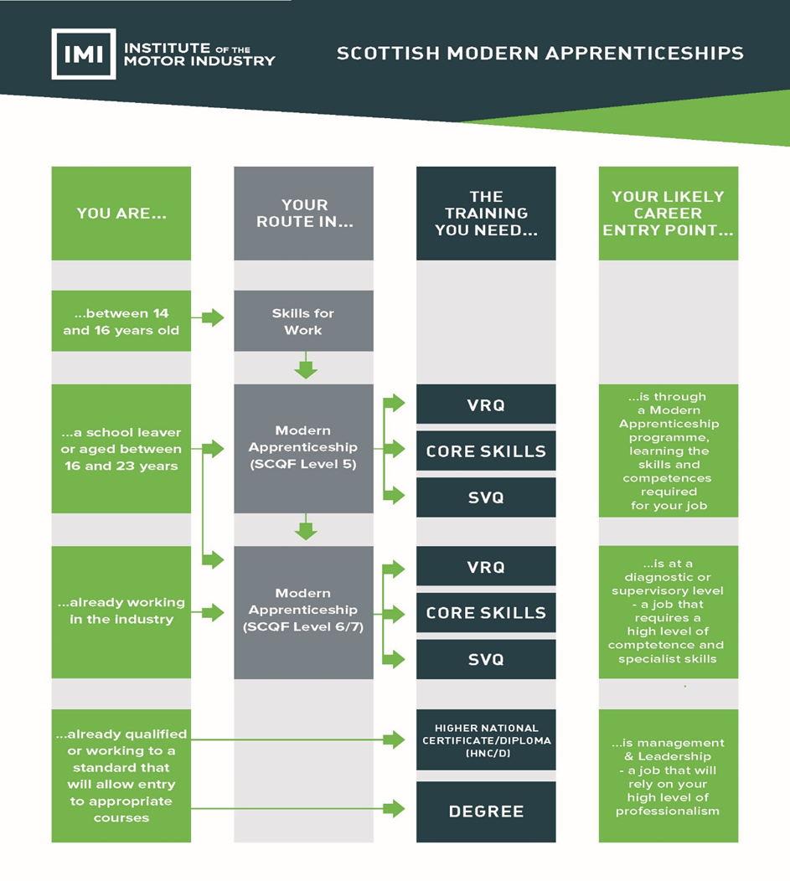
Light Vehicle Service Technician Heavy Vehicle Service Technician
Motorcycle Service Technician Lift Truck Service Technician
Vehicle Inspector Body Repair Technician
Paint Technician Parts Adviser
Specialist Tyre Fitter MET Technician
Fast-Fit (Vehicle Fitting) Technician

Skills for Work courses and full time college based programmes all provide valid entry routes to the SCQF Level 5 Modern Apprenticeship and opportunities will also exist for candidates to progress to an SCQF level 6 or & Modern Apprenticeship in Automotive.

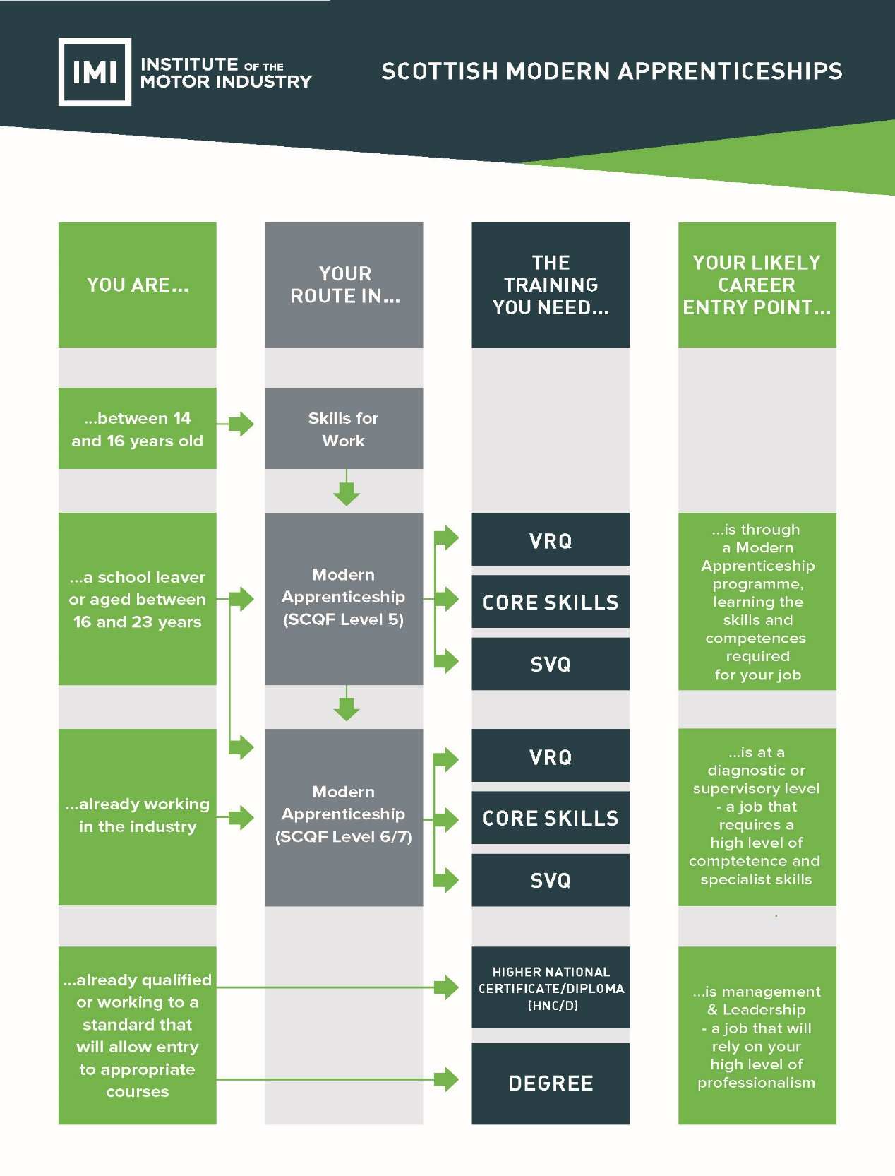
Appendices

APPENDIX 1

Stakeholder Responsibilities

Many organisations and individuals share the responsibility for ensuring that the Modern Apprenticeship programme is implemented to the highest possible standard. They include:

- Awarding Bodies
- Employers
- Modern Apprentices
- Modern Apprenticeship Group (MAG)
- Sector Skills Councils (SSCs)
- Skills Development Scotland
- Training Providers

Role of the Sector Skills Councils

SSCs are responsible for developing Modern Apprenticeship Frameworks and are required to work with employers in their sectors to ensure that all Frameworks meet the needs of employers in their sectors.

For details on your sector’s SSC visit http://fisss.org/

Role of Skills Development Scotland

MA frameworks are used by employers as part of their workforce development to train new employees and up-skill existing members of staff. They can be (and often are) used regardless of whether financial support is available from the delivery body who currently provides a ‘contribution’ towards the cost of delivery. However, only approved MA Frameworks will be eligible for funding support from Skills Development Scotland who should be contacted to establish the availability and level of support for each MA Framework.

Further information is available from www.modernapprenticeships.com

Skills Development Scotland, under the Careers Scotland brand, provides advice and guidance to individuals on the range of Modern Apprenticeships and training providers available. Individuals are signposted to opportunity providers who offer training in the vocational areas of interest.

Responsibilities include:

-  Supporting the Modern Apprentice with ongoing Career Planning advice
-  Signposting candidates to suitable vacancies
-  Promoting the Modern Apprenticeship route on Career Scotland branded website
-  Facilitating recruitment events that bring together jobseekers and opportunity providers

Role of the Awarding Bodies

A significant proportion of the Modern Apprenticeship is based on the assessment of the apprentice against S/NVQs or S/NVQ units. These qualifications are accredited by the SQA Accreditation and the Office of the Qualifications and Examinations Regulator (Ofqual) and are offered by Awarding Bodies.

It is the responsibility of the Awarding Bodies to ensure that centres are approved, that assessors and verifiers are suitably qualified, trained and monitored, and that all of the assessment criteria of the S/NVQs and S/NVQ units are fully met.

Role of the Training Provider

The role of the training provider is important to the success of the Modern Apprenticeship. A training provider can be a further education college, a private or voluntary training company or in some cases the employer themselves or employer partnerships.

Training Providers are responsible for:

- Confirming an appropriate MA programme for candidates
- Agreeing the training needs of the candidates
- Agreeing roles and responsibilities for on the job training
- Agreeing where off the job training will be required and defining roles and responsibilities for this with relevant parties
- Ensuring trainee/candidate has access to the best quality training opportunities available
- Ensuring that the Modern Apprentices and employers fully understand the principles and processes of competence- based assessment
- Registering of MA candidates with the relevant SSC (and Skills Development Scotland if appropriate).
- Compiling and agreeing assessment schedules/assessment plans
- Judging performance evidence
- Completing assessment records
- Reviewing candidates progress at regular intervals
- Submitting records and evidence for moderation
- Advising the Modern Apprentice who to approach for support, advice, encouragement and in case of complaint

Role of Modern Apprenticeship Group (MAG)

MAG is an independent group drawn from key stakeholders involved in the management and delivery of the Modern
Apprenticeship programme in Scotland.

MAG is responsible for:

- Approval and re-approval of MA Frameworks
- De-approval of MA Frameworks
- Overseeing the generic marketing thrust of the MA programme in Scotland
- Encouraging best practice across MA Frameworks and sectors

Role of the Employer

Employers’ responsibilities include:

- Paying all Modern Apprentices in accordance with company policy and in line with current legislation
- Agreeing roles and responsibilities for on the job training
- Agreeing where off the job training will be required and define roles and responsibilities for this with relevant parties
- Highlighting opportunities for the Modern Apprentice to demonstrate competence
- Meeting with Trainers, Assessors, Verifiers and the Modern Apprentices to review progress
- Witnessing candidate performance and verifying evidence
- Releasing Modern Apprentices for college/off-the-job training in line with training plan
- Ensuring the experience, facilities and training necessary to achieve the outcomes of the training plan.
- Supporting and encouraging Modern Apprentices and rewarding achievement
- Taking responsibility for the Health & Safety of Modern Apprentices.

Role of the Modern Apprentice

Modern Apprentices have the same responsibilities to their employer as any other employee. In addition they have a range of commitments to their training programme.

Modern Apprentices’ responsibilities include:

- Observing the company’s terms and conditions of employment
- Agreeing a training/development plan with all parties involved
- Undertaking development in line with agreed training plan
- Attending meetings with trainers, assessors and verifiers as required
- Attending college/off-the-job training where required
- Providing evidence of competence
- Developing a collection of evidence (portfolio) and retain ownership of this throughout
- Behaving in a professional manner throughout

APPENDIX 2

Modern Apprenticeship Centres (MACs)

Modern Apprentices may only be registered through organisations approved by the SSC to deliver this Framework. Such approved organisations are called Modern Apprenticeship Centres (MACs)

The MAC may be the employer of the apprentice or a separate organisation such as a training provider, further education college, a private or voluntary training company or in some cases the employer themselves or employer partnerships.

In order to be approved, organisations must make a formal application to the SSC, seeking approval and establishing that the centre satisfies the following criteria:

Either

1 be approved by an appropriate Awarding Body as a centre for the assessment of the relevant S/NVQ(s) (and Core
Skills if these are being separately certificated)

or

2 be capable of demonstrating a contractual relationship with another approved centre for the assessment of those units for which the MAC does not have approval from an appropriate Awarding Body.

In addition

The SSC will maintain a database of MACs for the delivery of the Framework within Scotland, which will be available to employers and others.

Organisations wishing to become MACs who have yet to obtain the necessary Awarding Body approval for assessment should first contact the Awarding Body direct.

Organisations wishing to be accredited with SQMS (or other appropriate quality system) should contact Skills Development
Scotland.

In addition to the assessment of the Modern Apprentice against the relevant standards set by the selected Framework outcomes, the MAC has responsibility for:

- Entering into a formal training agreement with the employer and Modern Apprentice
- Registering Modern Apprentices as candidates for the relevant S/NVQ(s) and other selected units with the appropriate Awarding Body
- Registering Modern Apprentices with the SSC
- Applying for the final `Certificate of Completion’ on behalf of Modern Apprentices
- Informing the SSC of any material alterations to Modern Apprentices’ training plans or desired changes to the selected Framework outcomes.

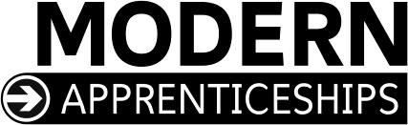APPENDIX 3

MODERN APPRENTICESHIP SAMPLE TRAINING AGREEMENT

This Training Agreement is entered into by:

Name of Employer:
Name of Modern Apprentice:
Name of Modern Apprenticeship
Centre:

The Employer’s responsibilities are to:

1 employ the modern apprentice subject to the employer’s usual terms and conditions of employment;

2 provide the modern apprentice with the facilities, training and work place opportunities necessary to achieve the selected Framework
outcomes specified in the apprentice’s personal training plan;

3 pay the modern apprentice an agreed salary which reflects the obligations of the employer and the opportunities for the apprentice;

4 in the event of the employer becoming unable to retain the modern apprentice after completion of the apprenticeship, to use reasonable endeavours to secure employment elsewhere;

5 in the event of the apprenticeship being terminated prematurely by either the employer or modern apprentice for any reason other than dismissal for unsatisfactory performance or misconduct, to use reasonable endeavours to secure employment and continuation of this apprenticeship elsewhere;

6 operate a formal Health and Safety policy and undertake the necessary legal and contractual responsibilities for health and safety of the modern apprentice; and

7 operate an Equal Opportunities policy which meets all legal requirements.

The Modern Apprentice’s responsibilities are to:

1 work for the employer in accordance with the agreed terms and conditions of employment;

2 undertake training, attend courses if required, keep records, and take assessments to be determined by the employer and/or Modern Apprenticeship Centre, and carry out such work as may be required in order to achieve the selected Framework outcomes specified in the apprentice’s personal training plan;

3 be diligent, punctual, behave in a responsible manner and in accordance with the requirements of Health and Safety legislation relating to the
Apprentice’s responsibilities as an individual; and

4 promote at all times the employer’s best interests.

The Modern Apprenticeship Centre’s responsibilities are to:

1 agree the content of the modern apprentice’s personal training plan as confirming that the selected Framework outcomes and training plans meet the criteria of this modern apprenticeship

2 contract with the employer to provide the training and assessment necessary to enable the modern apprentice to achieve the selected
Framework outcomes specified in the apprentice’s personal training plan; and

3 use its best endeavours to ensure that the employer provides the modern apprentice with the facilities, training and work place opportunities necessary to achieve the selected Framework outcomes specified in the apprentice’s personal training plan.

This agreement to be signed by all parties:
Employer |  | Date:
Modern Apprentice  (or Parent/Guardian, if under 18) |  | Date:
Modern Apprenticeship Centre |  | Date:

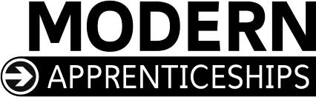

MODERN APPRENTICESHIP TRAINING PLAN

The Modern Apprenticeship Centre
Name:

Address:

Telephone:

Contact:

The Modern Apprentice
Full name:

Home address:

Work address:

Date of birth:

The Employer
Name:

Address:

Telephone:

Contact:

The Local Enterprise Company (if applicable)
Name:

Address:

Telephone:

Contact:

Framework selected outcomes
Mandatory outcomes

S\NVQ Level (please identify level)  (List mandatory and optional units) |  | Tick units being  undertaken | SCQF Level | SCQF Credit  Points
S\NVQ level (please identify level )
(List mandatory and optional units)
Enhancements

Core Skills  (Include details of the minimum level required) |  | Tick units being  undertaken | SCQF Level | SCQF Credit  Points
1 | Communication
2 | Working with others
3 | Numeracy
4 | Information technology
5 | Problem Solving

Optional outcomes

Additional units (if any)  These are optional and should reflect the individual training needs of the Apprentice |  | Tick units being  undertaken | SCQF Level | SCQF Credit  Points
 | (specify unit)
 | (specify unit)
 | (specify unit)
 | (specify unit)

Summary of Modern Apprentices accredited prior learning:

If you require assistance in completing this form, please contact:

Institute of the Motor Industry (IMI) Fanshaws
Brickendon Hertford SG13 8PQ
Tel: 01992 519039
Fax: 01992 511548

